1 run......

Downloading: 100%

411/411 [00:00<00:00, 13.1kB/s]

Downloading: 100%

263M/263M [00:09<00:00, 30.3MB/s]

training 1 epoch...

140.1554615497589 seconds used......

1 training finished! average train loss: 0.8613503251873186

evaluating...

Confusion matrix, without normalization

[[ 0 48 76]

[ 1 83 80]

[ 0 85 780]]

Normalized confusion matrix

[[0. 0.38709677 0.61290323]

[0.00609756 0.50609756 0.48780488]

[0. 0.0982659 0.9017341 ]]

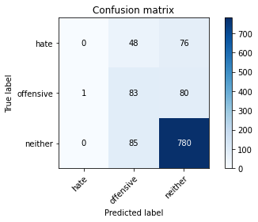

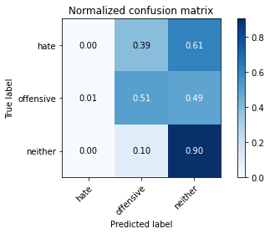

precision recall f1-score support

hate 0.00 0.00 0.00 124

offensive 0.38 0.51 0.44 164

neither 0.83 0.90 0.87 865

accuracy 0.75 1153

macro avg 0.41 0.47 0.43 1153

weighted avg 0.68 0.75 0.71 1153

average eval_loss: 0.7467031591925127, accuracy: 0.7484822202948829

training 2 epoch...

138.98046803474426 seconds used......

2 training finished! average train loss: 0.7515038165419582

evaluating...

Confusion matrix, without normalization

[[ 44 18 62]

[ 32 40 92]

[ 90 27 748]]

Normalized confusion matrix

[[0.35483871 0.14516129 0.5 ]

[0.19512195 0.24390244 0.56097561]

[0.10404624 0.03121387 0.86473988]]

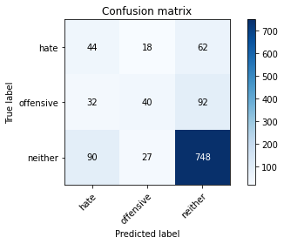

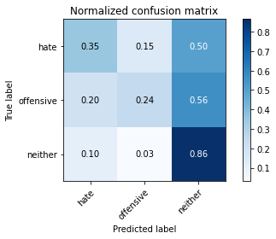

precision recall f1-score support

hate 0.27 0.35 0.30 124

offensive 0.47 0.24 0.32 164

neither 0.83 0.86 0.85 865

accuracy 0.72 1153

macro avg 0.52 0.49 0.49 1153

weighted avg 0.72 0.72 0.71 1153

average eval_loss: 0.7265709515275627, accuracy: 0.7215958369470945

training 3 epoch...

139.1490204334259 seconds used......

3 training finished! average train loss: 0.6005209545531778

evaluating...

Confusion matrix, without normalization

[[ 64 30 30]

[ 58 63 43]

[258 55 552]]

Normalized confusion matrix

[[0.51612903 0.24193548 0.24193548]

[0.35365854 0.38414634 0.26219512]

[0.2982659 0.06358382 0.63815029]]

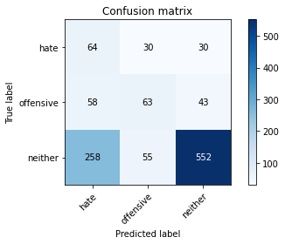

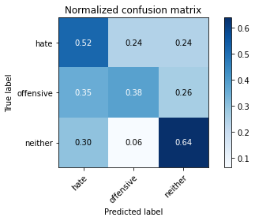

precision recall f1-score support

hate 0.17 0.52 0.25 124

offensive 0.43 0.38 0.40 164

neither 0.88 0.64 0.74 865

accuracy 0.59 1153

macro avg 0.49 0.51 0.47 1153

weighted avg 0.74 0.59 0.64 1153

average eval_loss: 0.8929048838286564, accuracy: 0.5888985255854293

training 4 epoch...

139.1558222770691 seconds used......

4 training finished! average train loss: 0.3763087020087161

evaluating...

Confusion matrix, without normalization

[[ 25 48 51]

[ 20 90 54]

[ 98 103 664]]

Normalized confusion matrix

[[0.2016129 0.38709677 0.41129032]

[0.12195122 0.54878049 0.32926829]

[0.1132948 0.11907514 0.76763006]]

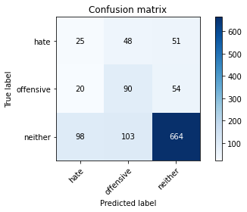

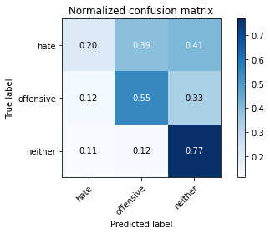

precision recall f1-score support

hate 0.17 0.20 0.19 124

offensive 0.37 0.55 0.44 164

neither 0.86 0.77 0.81 865

accuracy 0.68 1153

macro avg 0.47 0.51 0.48 1153

weighted avg 0.72 0.68 0.69 1153

average eval_loss: 0.8681121257872417, accuracy: 0.6756287944492628

training 5 epoch...

139.30303478240967 seconds used......

5 training finished! average train loss: 0.18611794488930458

evaluating...

Confusion matrix, without normalization

[[ 51 28 45]

[ 35 69 60]

[185 74 606]]

Normalized confusion matrix

[[0.41129032 0.22580645 0.36290323]

[0.21341463 0.42073171 0.36585366]

[0.21387283 0.08554913 0.70057803]]

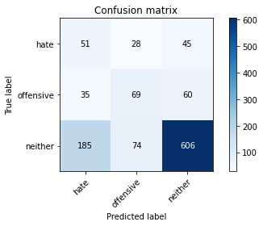

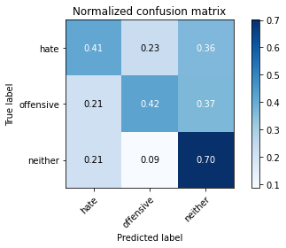

precision recall f1-score support

hate 0.19 0.41 0.26 124

offensive 0.40 0.42 0.41 164

neither 0.85 0.70 0.77 865

accuracy 0.63 1153

macro avg 0.48 0.51 0.48 1153

weighted avg 0.72 0.63 0.66 1153

average eval_loss: 1.2239374790726036, accuracy: 0.629661751951431

2 run......

training 1 epoch...